PROJECT DESIGN PHASE
PROBLEM – SOLUTION
Date
Team ID | SWTID-2026-3317 _____________
Project Name | AI FAQ Assistant
Maximum Marks | 2 Marks

Problem – Solution Fit Template
The Problem-Solution Fit checks whether the identified customer problem is addressed by the proposed solution. For the AI FAQ Assistant, the customer's difficulty in finding quick and reliable answers is directly addressed through a centralized AI-powered FAQ system.
Purpose for this project
- Understand the existing difficulties faced by FAQ users.
- Provide a solution that fits the user's need for quick and reliable information.
- Reduce repetitive questions and support effort.
- Improve user experience through a simple conversational interface.
- Build trust by providing consistent and relevant answers.

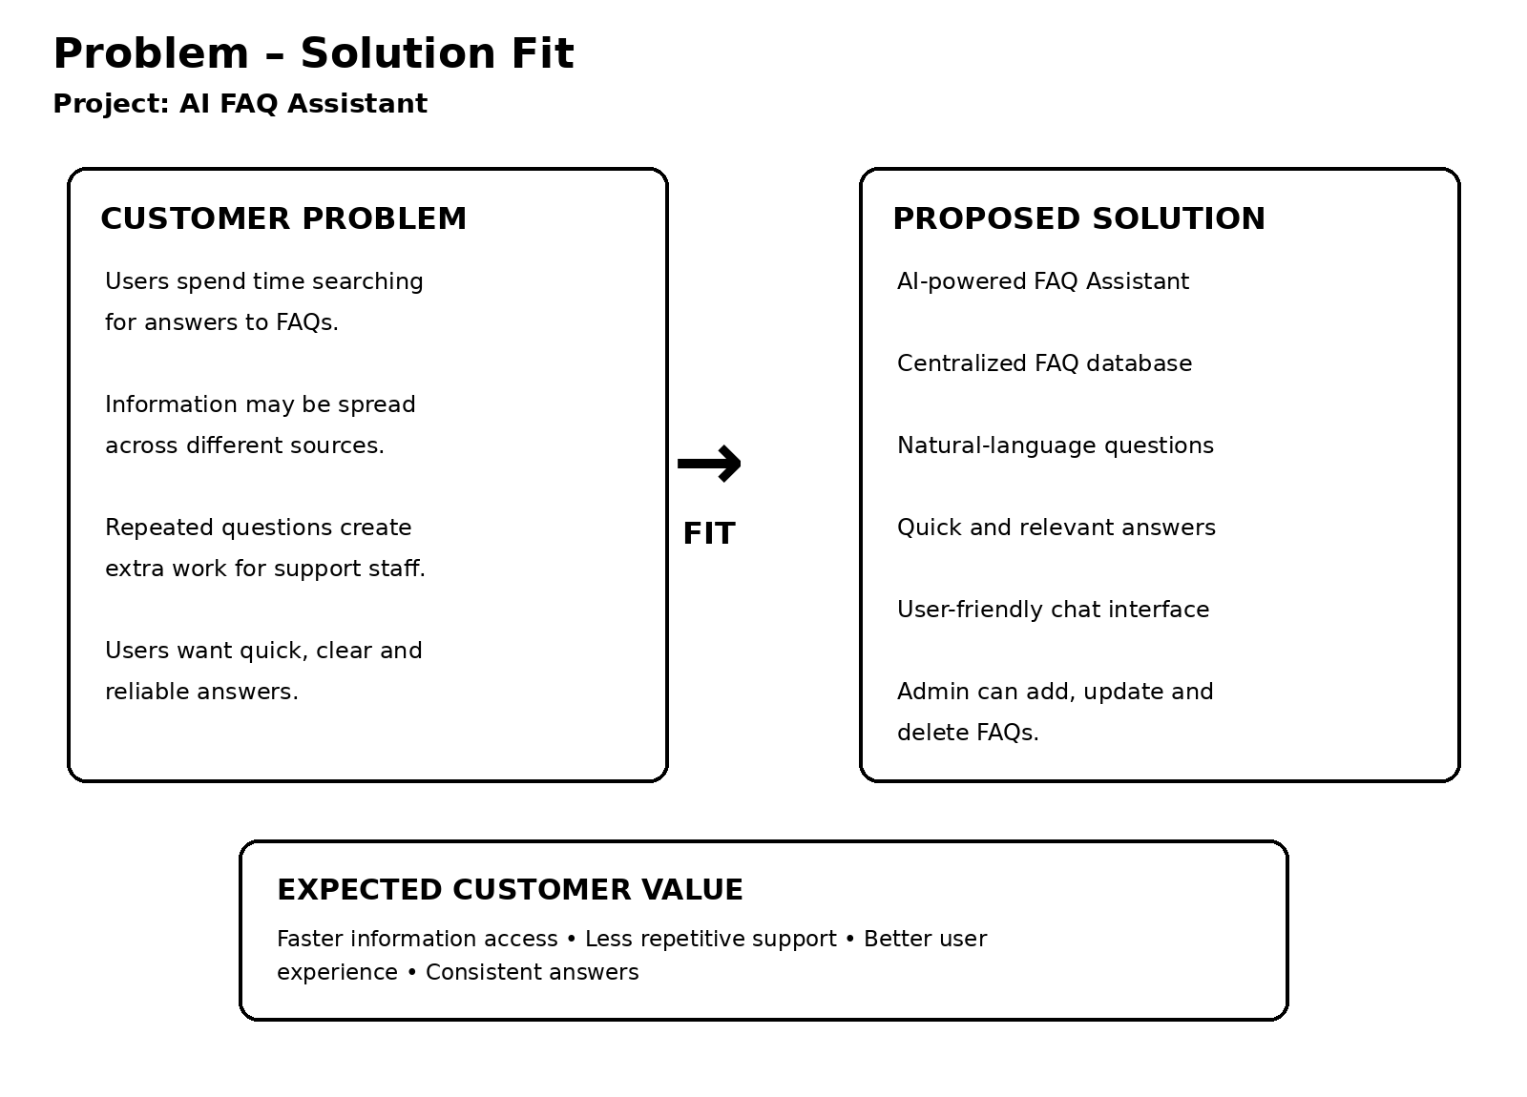

Problem – Solution Fit Details
Customer Problem | AI FAQ Assistant Solution
Users spend too much time searching for FAQ answers. | The AI FAQ Assistant gives quick answers through a single interface.
Information is spread across different sources. | A centralized FAQ database stores frequently needed information.
Users may ask questions in natural language. | The system accepts natural-language queries and provides relevant responses.
Support staff answer the same questions repeatedly. | The FAQ system handles common questions automatically.
Users need clear and consistent information. | The system provides structured, easy-to-understand answers from the available FAQ information.

Problem-Solution Fit Statement: The AI FAQ Assistant fits the identified customer problem by centralizing frequently asked questions and providing quick, relevant and easy-to-understand responses, reducing search time and repetitive support work.

